Configuring the ODBC Connection
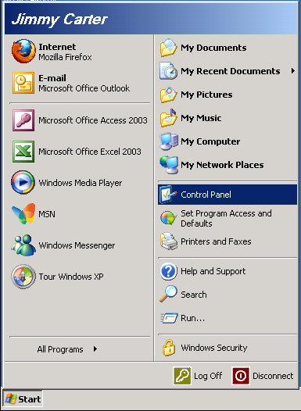
Click the Start button. Double Click “Control Panel”
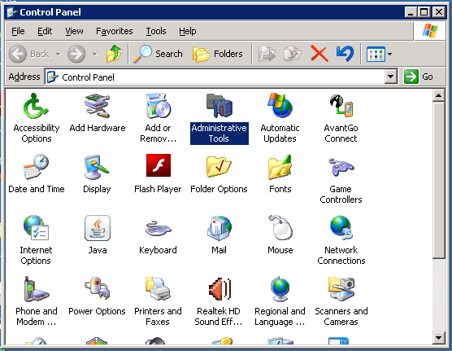
Double Click on “Administrative Tools”
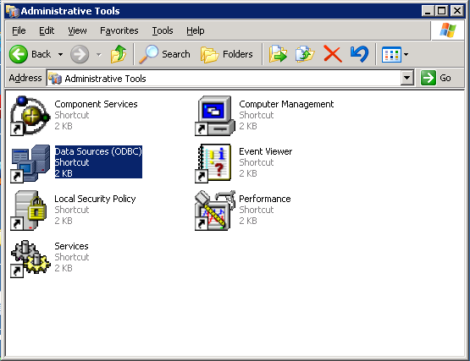
Double Click on Data Sources (ODBC)
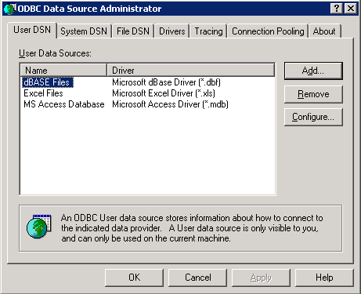
Click Add
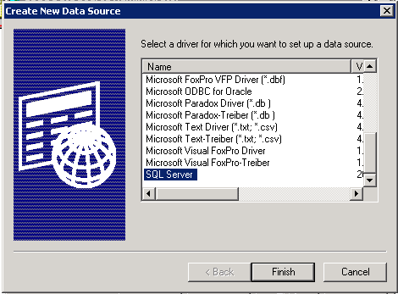
Select SQL Server at the bottom of the list and click Finish
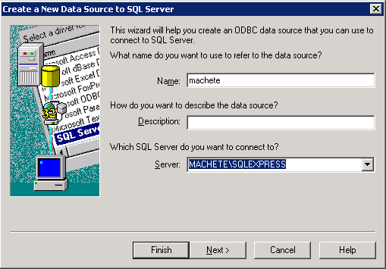
Type in the Name and Select the Server, then click Next
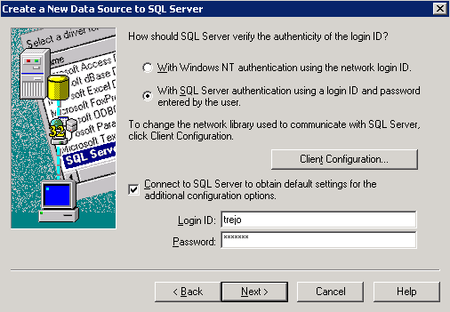
Select the “With SQL Server authentication” and click on “Connect to SQL Server to obtain…”
Enter trejo for the ID and machete for the password.
Click Next
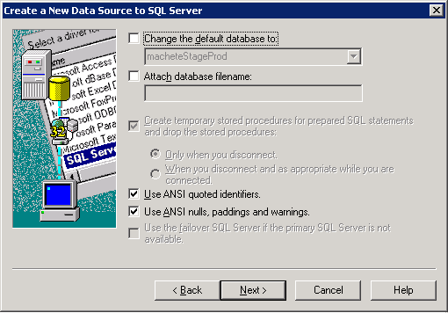
If you get an error, there is a network connectivity problem. If you get this screen, you are probably good.
Click Next
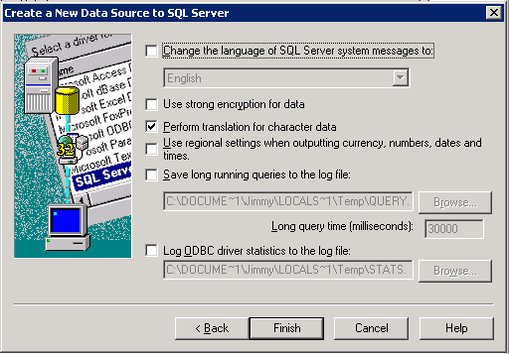
Click Finish
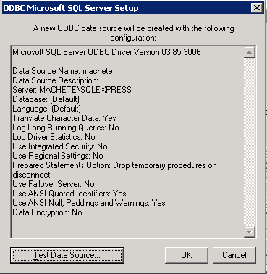
Click Test Data Source. If you don’t get a successful test, then there is probably a firewall or other permission problem on the server. Email jimmy@savagelearning.com or talk to Gabriel.
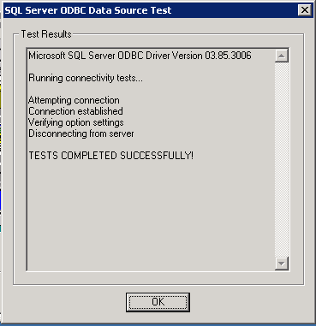
Click Ok. Click Ok again on the next screen.
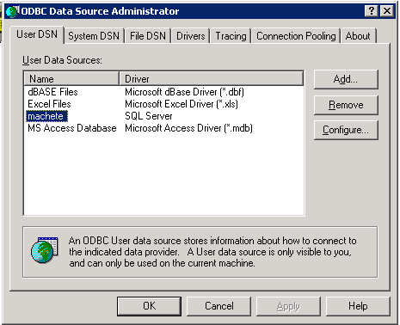
Great Success!
Open Excel
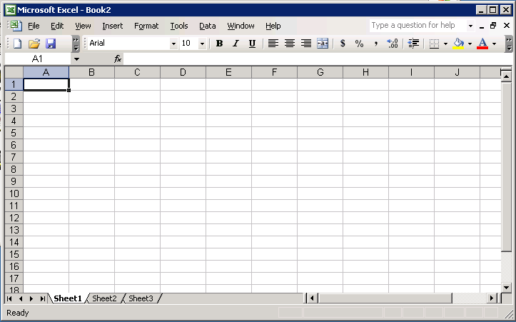
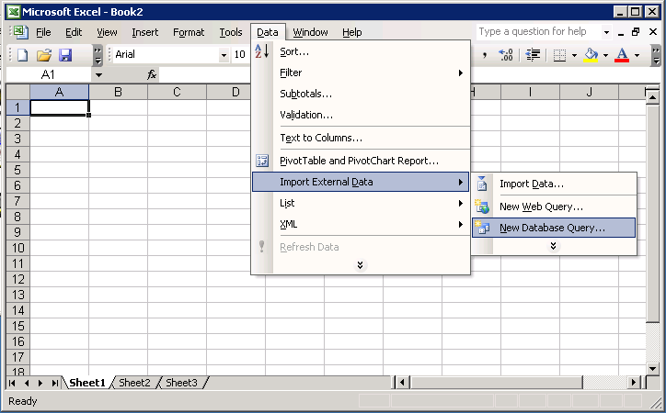
From the Data menu, select “Import external data”, then select “New database query”
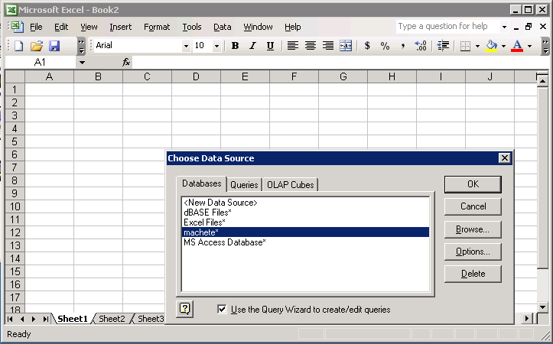
Select machete from the dialog
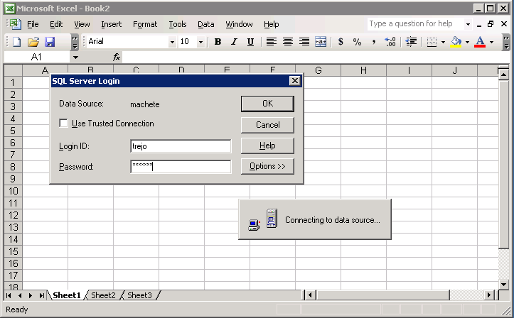
The ID is trejo and the password is machete
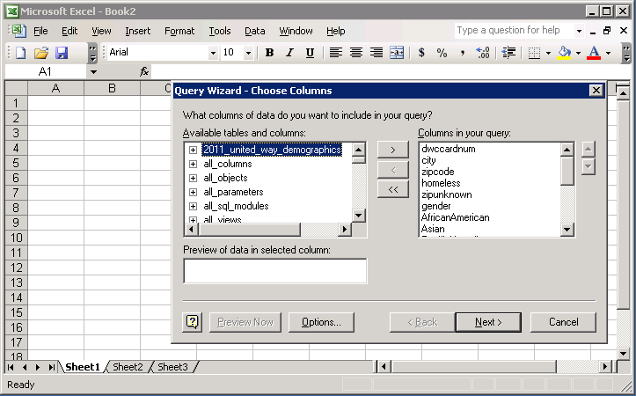
Select the “2011_united_way_demographics” table
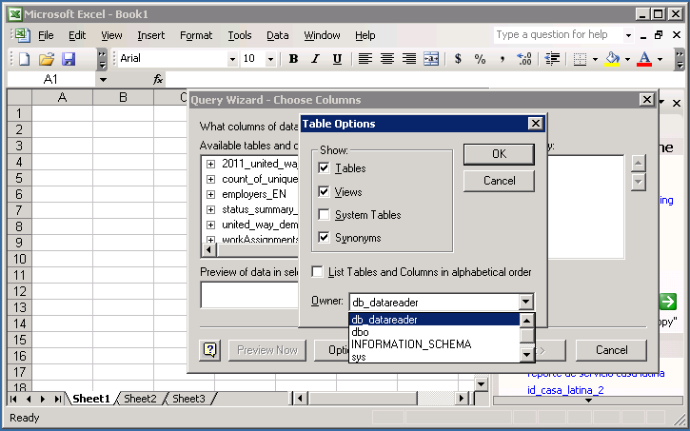
Note: If you click Options and change the options to only show objects owned by “db_datareader”, the list will not be full of things you don’t care about. (see above)
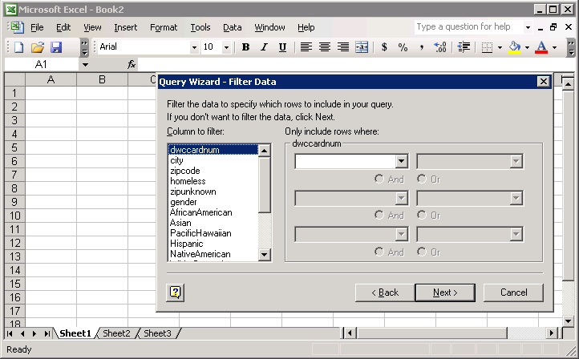
The data is already filtered, so you don’t need to do anything here. Click next.
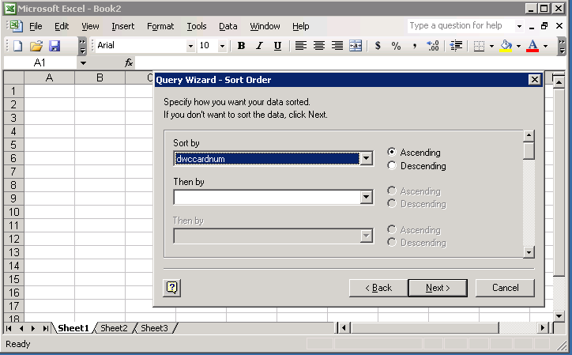
Select a column to sort by. The example uses the card number of the worker
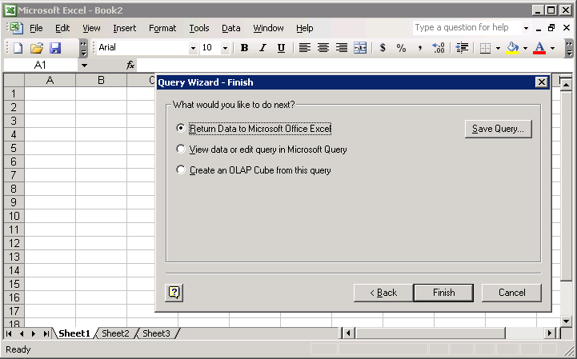
Select “return data to Microsoft Excel” and click finish
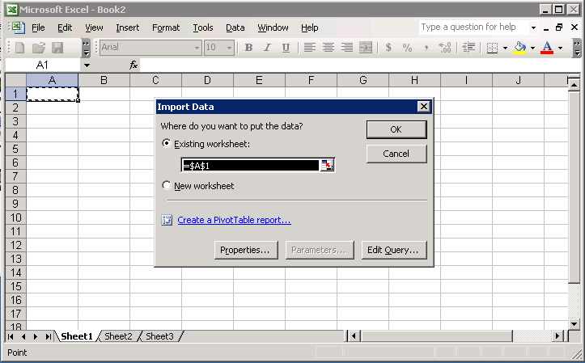
Identify where to import the data.
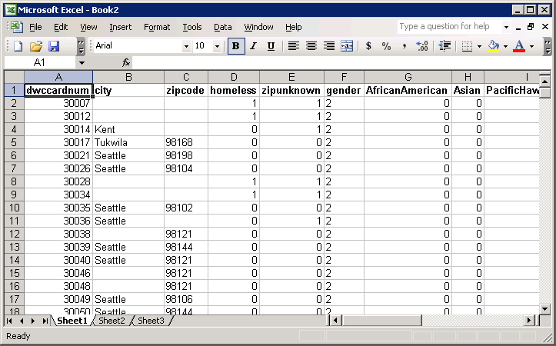
Great Success!

